**22BCE0476**

**AMAN CHAUHAN**



BCSE308P - Computer Networks Lab

LAB REPORT

**IP Error:**

**Code:**

import socket  
  
  
def get_ip_from_hostname(hostname):  
 try:  
 # Get the IP address of a given hostname  
 ip_address = socket.gethostbyname(hostname)  
 print(f"IP address of {hostname}: {ip_address}")  
  
 # Get all IP addresses associated with the hostname (if multiple exist)  
 ip_addresses = socket.gethostbyname_ex(hostname)[2]  
 print(f"All IP addresses for {hostname}: {', '.join(ip_addresses)}")  
 except socket.gaierror as e:  
 print(f"Error resolving {hostname}: {e}")  
  
  
def get_hostname_from_ip(ip_address):  
 try:  
 # Get the hostname for a given IP address  
 hostname = socket.gethostbyaddr(ip_address)[0]  
 print(f"Hostname for IP {ip_address}: {hostname}")  
 except socket.herror as e:  
 print(f"Error resolving {ip_address}: {e}")  
  
  
# Example usage  
hostname = "www.yahoo.com"  
get_ip_from_hostname(hostname)  
  
ip_address = "66.94.230.32"  
get_hostname_from_ip(ip_address)

Output:

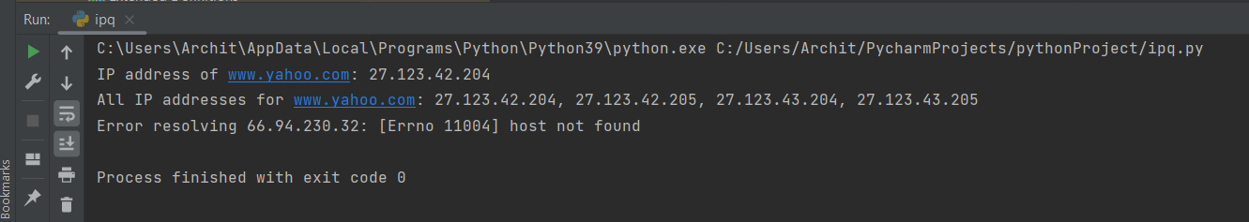

IP Header:

import socket  
import struct  
  
# Sample IPv4 packet (20-byte header with sample values)  
# Version (4) + IHL (5), TOS, Total Length, ID, Flags + Fragment Offset, TTL, Protocol (TCP), Header Checksum, Source IP, Destination IP  
ipv4_sample_packet = b'\x45\x00\x00\x3c\x1c\x46\x40\x00\x40\x06\xb1\xe6\xc0\xa8\x00\x68\xc0\xa8\x00\x01'  
  
# Sample IPv6 packet (40-byte header with sample values)  
# Version (6) + Traffic Class + Flow Label, Payload Length, Next Header (TCP), Hop Limit, Source IP (16 bytes), Destination IP (16 bytes)  
ipv6_sample_packet = (  
 b'\x60\x00\x00\x00\x00\x14\x06\x40' +  
 b'\xfe\x80\x00\x00\x00\x00\x00\x00\x02\x00\x5e\xff\xfe\x2a\x23\x45' +  
 b'\xfe\x80\x00\x00\x00\x00\x00\x00\x02\x00\x5e\xff\xfe\x2a\x23\x46'  
)  
  
def parse_ipv4_header(packet):  
 # Unpack the first 20 bytes of the packet for IPv4  
 ipv4_header = struct.unpack('!BBHHHBBH4s4s', packet[:20])  
  
 # Extract information from the unpacked header  
 version_ihl = ipv4_header[0]  
 version = version_ihl >> 4  
 ihl = version_ihl & 0xF  
 tos = ipv4_header[1]  
 total_length = ipv4_header[2]  
 identification = ipv4_header[3]  
 flags_offset = ipv4_header[4]  
 ttl = ipv4_header[5]  
 protocol = ipv4_header[6]  
 checksum = ipv4_header[7]  
 source_address = socket.inet_ntoa(ipv4_header[8])  
 destination_address = socket.inet_ntoa(ipv4_header[9])  
  
 print("IPv4 Header:")  
 print(f"Version: {version}")  
 print(f"IHL (Header Length): {ihl * 4} bytes")  
 print(f"TOS (Type of Service): {tos}")  
 print(f"Total Length: {total_length}")  
 print(f"Identification: {identification}")  
 print(f"Flags and Offset: {flags_offset}")  
 print(f"TTL (Time to Live): {ttl}")  
 print(f"Protocol: {protocol}")  
 print(f"Header Checksum: {checksum}")  
 print(f"Source Address: {source_address}")  
 print(f"Destination Address: {destination_address}")  
 print("\n")  
  
def parse_ipv6_header(packet):  
 # Unpack the first 40 bytes of the packet for IPv6  
 ipv6_header = struct.unpack('!IHBB16s16s', packet[:40])  
  
 # Extract information from the unpacked header  
 version_traffic_flow = ipv6_header[0]  
 version = version_traffic_flow >> 28  
 traffic_class = (version_traffic_flow >> 20) & 0xFF  
 flow_label = version_traffic_flow & 0xFFFFF  
 payload_length = ipv6_header[1]  
 next_header = ipv6_header[2]  
 hop_limit = ipv6_header[3]  
 source_address = socket.inet_ntop(socket.AF_INET6, ipv6_header[4])  
 destination_address = socket.inet_ntop(socket.AF_INET6, ipv6_header[5])  
  
 print("IPv6 Header:")  
 print(f"Version: {version}")  
 print(f"Traffic Class: {traffic_class}")  
 print(f"Flow Label: {flow_label}")  
 print(f"Payload Length: {payload_length}")  
 print(f"Next Header: {next_header}")  
 print(f"Hop Limit: {hop_limit}")  
 print(f"Source Address: {source_address}")  
 print(f"Destination Address: {destination_address}")  
 print("\n")  
  
# Parse the sample packets  
print("Parsing Sample IPv4 Packet:")  
parse_ipv4_header(ipv4_sample_packet)  
  
print("Parsing Sample IPv6 Packet:")  
parse_ipv6_header(ipv6_sample_packet)

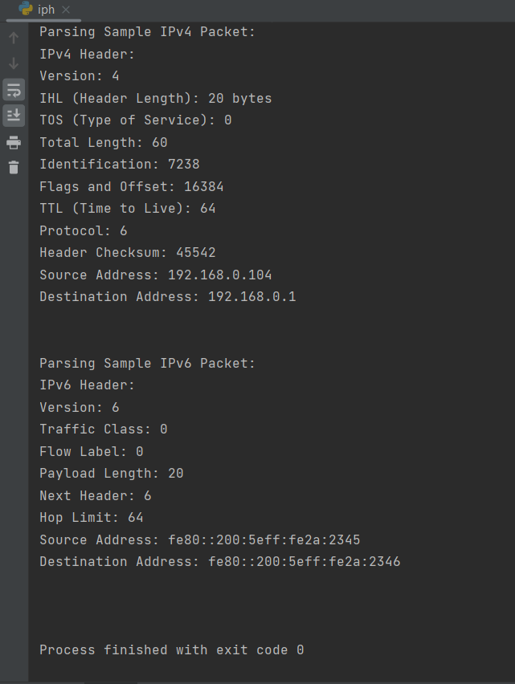

SLACC Configuration and EUI-68:

